1920’s Trends and Fashion
Some of the most exciting and memorable elements of the 1920s in America are the trends. One memorable dance developed in the 1920s was the Charleston. Other trends in entertainment came in the movie industry. Who can forget talkies and Charlie Chaplin? Further, some of the most famous people of the 1920s were flappers. These women set fashion trends for years to come.
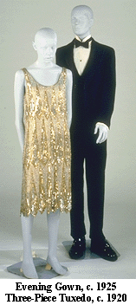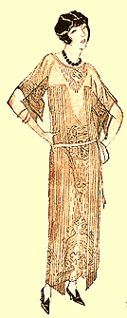
Check out the following site for information on flappers and fashions of the 1920s.
http://www.pandorasbox.com/flapper.html

