Famous People of the Jazz Age:
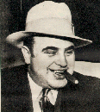
Al "Scarface" Capone
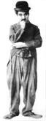
Charlie Chaplin
"The Little Tramp"
The 1920s in America produced many famous people. Among writers of the time period, names like F. Scott Fitzgerald and Ernest Hemingway prevail among what became known as "the lost generation." Fitzgerald wrote This Side of Paradise as a portrait of life in the early twenties. In addition, his novel The Great Gatsby portrayed not only lifestyles of the rich during the time period but also lifestyles of the Fitzgeralds during the climax of their life together. Fitzgerald's novel mentions two famous people--Dan Coty and Meyer Wolfsheim. During the time period, there were many famous people. Examples of these are Al Capone, Charlie Chaplin, Henry Ford, Gaston Chevrolet, "Bugs" Moran, and Clara Bow. The Volstead Act of 1919 gave life to such characters as Bugs Moran and Al Capone. One famous, mysterious incident between the two men was the St. Valentine's Day Massacre. The mystery around the murders still provokes curiosity today. In the infant stages of the movie industry, one famous little tramp emerged -- Charlie Chaplin. People continue to celebrate the acting abilities he pioneered in the twenties. One other famous person to recognize is Clara Bow. Her perfectly puckered lips became an icon of the age. Music of the twenties produced famous people such as Louis Armstrong and Duke Ellington. The American music style became jazz. These peoples' popularity at the time provides us valuable information to reflect on the 1920s. In addition, the radio industry experienced many changes. Further searches produce many more names and accomplishments.
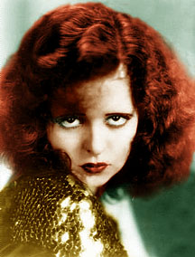
Clara Bow
Babe Ruth
Charles Lindbergh
The Chicago Black Sox

